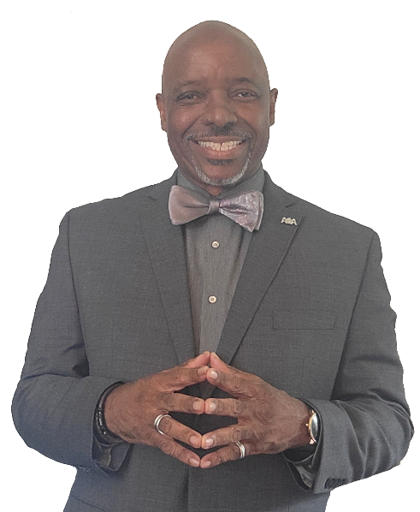
Garry M. Spotts is a native of Louisville, KY. The son of the late Elder George M. Spotts and Mrs. Viola Spotts-Dawson, Elder Spotts is one of four siblings: a sister, Vanessa Spotts, his twin brother, Elder Greg M. Spotts, and a younger brother, The Late, Sammy “Shake” Anderson.
Elder Spotts shared his life with his Beloved, late wife, Dr. Annette Carlisle-Spotts, his college sweetheart, whom God called to eternal rest in January of 2024. Together, they are the parents of three children: Jessica Carlisle, the late Gyasi M. Spotts, and Shukura Spotts. They have four grandsons, GeMari M. Spotts, Aidan Adams, Aniken Adams, Atlas Adams, and a granddaughter, Aniyah Adams.
Elder Spotts was compelled to ministry in late 1975 and preached his initial sermon on Sunday, March 28, 1976, under the pastorate of his mentor, Rev. Dr. H. Donald Cockerham, now pastor emeritus of the Zion Missionary Baptist Church of Louisville, KY. He is a 1982 alumnus of the University of Kentucky Grehan School of Journalism and a 1987 Master of Divinity graduate of The Southern Baptist Theological Seminary. He was ordained in the Zion Baptist Church by Elder Cockerham in 1989.
He has served professionally as:
- the Academic Dean of Simmons Bible College of Kentucky (presently know as Simmons College of Kentucky),
- a First Year Student Advisor at Miami University of Ohio,
- the Assistant Pastor of the Pilgrim Baptist Church of Hamilton, Ohio with his much-beloved mentor and friend, the late Rev. Dr. Norman L. Townsel, Sr.,
- The Executive Director of the St. Stephens Baptist Church Family Life Center,
- Minister of Church Development at St. Stephen Baptist Church,
- Minister of Education and Staff Development alongside his Father, Mentor and Friend in the Ministry, Rev. Dr. H. Donald Cockerham, the pastor emeritus of Zion Baptist Church of Louisville, KY, and most recently,
- As Pastor of the Bethesda Missionary Baptist Church of Louisville, KY from September 2010 until March 2017.
- Serves as the editor-in-chief of the American Baptist News, an objective of the General Association of Baptists in Kentucky, and chair of the American Baptist Publishing Board.
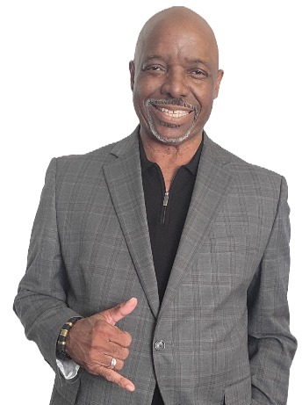
- Co-founder of Archology Resource Group, LLC, a recently formed think tank consultancy.
Garry M. Spotts is a proud member of the Alpha Phi Alpha Fraternity, Inc., and has served at the local, district, and regional levels within his fraternity. He proudly serves as the chair and executive director of the Alpha Lambda Center For Excellence Foundation, Inc.
Elder Garry M. Spotts is a sought-after conference and workshop speaker who addresses topics vital to the future of the church in discipleship, ministry development, the 21st-century Church, The De-Churched Movement, and trends that impact the church.
Outside of ministry, Garry Spotts has operated a consulting practice, Weboniqs Media, LLC d/b/a Garry M. Spotts Consulting, since 1993, serving small businesses, non-profits, churches, schools, and educators as a trainer, business and organizational development consultant, and ministry developer.
He is the author of seven books, two collections of original poetry, four children’s books, and a Christian discipleship book entitled “Ruach Elohim: The Ancient and Ongoing Work of The Holy Spirit. Along with one that is nearing completion, a personal empowerment book, “Life Leaves Clues,” Real Wisdom for Today’s Challenges.
With nearly five decades of progressive and diverse ministry experience, Elder Spotts is even more convicted of the need for:
- The Gospel in the lives of the unsaved and saved alike, and
- The Power of the Holy Spirit for every growth-hungry disciple of Jesus Christ.
His love for teaching is only outpaced by his passion for the people he teaches.
He says the best way to introduce him is to say, “I Love The Lord, I Listen for The Holy Spirit’s Leading, and Love serving Our God by actively loving the people of God! Nothing gives me more joy or satisfaction than watching the people of God transformed by His Word.”

